F – Intento de Transacción de Combustible Distinto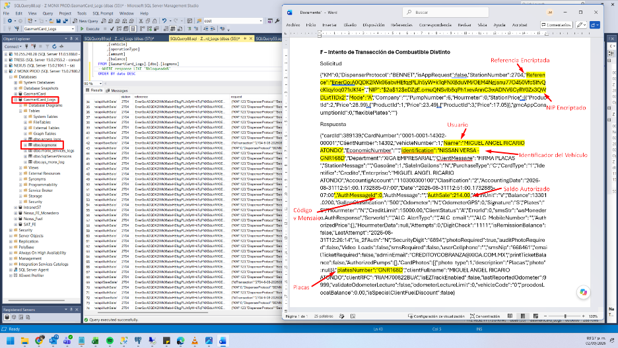
Solicitud
{"KM":0,"DispenserProtocol":"BENNET","isAppRequest":false,"StationNumber":2704,"Reference":"EnerGo:A0QDK2IWk06abvHEfqgPLJh5yW+kTqFNXBduVM/OEM4Ngjsnu77O450VfcSIfvQcKlqyIoq07fxJKf4=","NIP":"$2a$12$eDZgE.omuQNSvIb8qPh1xevAnnC3wADNV6CyRY0Zx3QWDLvtTIDx2","Mode":"A","Company":"","PumpNumber":6,"Hourmeter":0,"StationPrice":[{"ProductId":2,"Price":28.99},{"ProductId":1,"Price":23.49},{"ProductId":3,"Price":17.05}],"gmcAppConsumptionId":0,"flexiblePlates":""}
Respuesta
{"cardId":389139,"CardNumber":"0001-0001-14302-00001","ClientNumber":14302,"vehicleNumber":1,"Name":"MIGUEL ANGEL RICARIO ATONDO","EconomicNumber":"","Identification":"NISSAN VERSA -GNR168D","Department":"XIGA EMPRESARIAL","ClientMessage":"FIRMA PLACAS ","StationMessage":"","Gasoline":1,"SaleInGallons":"N","PurchaseType":"C","CardType":"1","Identifier":"Credito","Enterprise":"MIGUEL ANGEL RICARIO ATONDO","AccountigAccount":"110300300100","Clasification":"2","AccountingDate":"2026-08-31T12:51:00.1732885-07:00","Date":"2026-08-31T12:51:00.1732885-07:00","AuthMessageId":0,"AuthMessage":"","AuthSale":214.00,"AuthUnit":"V","Balance":13301.0200,"GallonClasification":"500","Odometer":"N","OdometerGPS":0,"Signature":"S","Plates":"S","Hourmeter":"N","CreditLimit":15000.00,"ClientStatus":"A","ErrorId":0,"smsStr":"wsMonedero.AuthResponse","ServerId":"","ALC_AlertType":"","ALC_email":"","ALC_MobileNumber":"","AuthorizedPrice":[],"HourmeterData":null,"Attempts":0,"DigitCheck":"1111","isRemissionBalance":false,"LastAttempt":"2026-08-31T12:26:14","is_2FAuth":"N","SecurityDigit":"6894","photoRequired":true,"auditPhotoRequired":false,"Video_Loads":false,"smsRequired":false,"userCellphone":"","smsNip":"668461","emailTicketRequired":false,"adminEmail":"CREDITOYCOBRANZA@XIGA.COM.MX","printTicketBalance":false,"AuthorizedPumps":[],"CardPhotos":[{"photo_type":1,"description":"Placas","photo":null}],"platesNumber":"GNR168D","clientFullname":"MIGUEL ANGEL RICARIO ATONDO","clientRFC":"RIAM700822BUA","isEZTrackEnabled":false,"lastReportedOdometer":9999,"validateOdometerLecture":false,"odometerLectureLimit":0,"vehicleCode":"0","proodosLocalBalance":0.00,"isSpecialClientFuelDiscount":false}

